**Information Literacy Module:**



**Database Lesson**

**Directions**: View the **Database** power point which is posted in Handouts in the Information Literacy Unit page link in your course on STInet. Then, answer the following questions:

1. What is the main difference between a database and a search engine?  
     
   
2. What type of sources should you expect to find when searching in a database?  
   **Scholarly literature which are focused on subject matter.**
3. What are some of the ‘limiters’ that you can use in search engines to narrow your search results?  
   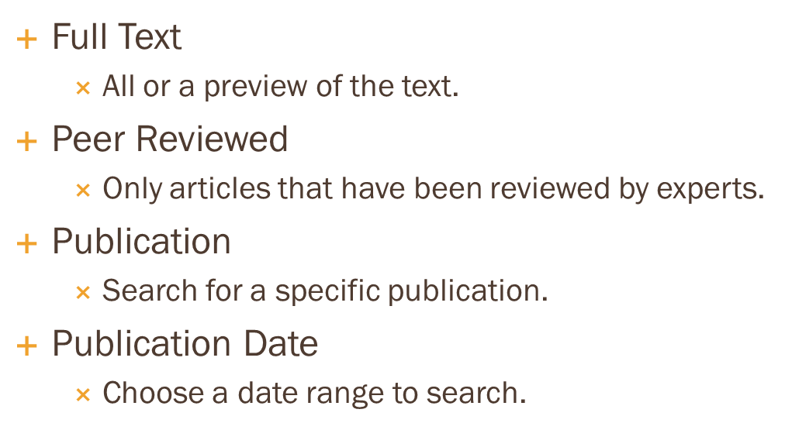
4. In a keyword search, will using several terms narrow or broaden your search results?  
   **Narrow**
5. Will most databases search a sentence or question that you typed in or do you have to break it down into search terms?  
   **No**
6. Name three (3) Boolean operators and explain how/why they are used.  
     
   **OR, AND, and NOT.**
7. Explain the term “nesting.”  
   **Use of Boolean operator to nest the search result in database and other sources.**
8. What are subject searches?  
     
   **Subject searches helps to search the list possible subjects.**
9. What is truncation used for?  
     
     
   **Truncation is used for searching database using asterisk(*) after end of word and it tells the database to search the word that have same prefix but different ending.**
10. What are the 2 electronic formats available to view full text database articles? Which is often considered easier to use when a person wants to know the exact pages?

**PDF and HTML. PDF is often considered easier to use when a person wants to know the exact pages.**